BillBanaoPay — Website Marketing & Product Brief
Brand: OmniDEL.ai
Product / domain: billbanaoppay.com
Audience: Any Indian SME that wants professional billing without enterprise software
Version: 2.0 · 2026-07-29
Use: Generate marketing website, sales FAQ, demo narrative

0. Brand hierarchy (do not mix)
| Layer | Name | Role |
|-------|------|------|
| **Company** | **OmniDEL.ai** | Builder / presenter of the product |
| **Product** | **BillBanaoPay** | The billing platform customers buy |
| **Domain** | **billbanaoppay.com** | Public product website |
Footer pattern: *BillBanaoPay by OmniDEL.ai*

1. One-line pitch
BillBanaoPay lets small businesses create professional invoices from Telegram or a photo of a handwritten slip — with optional GST, stored PDFs, payment tracking, and an owner login to see collections.

2. Who it is for (generic — not industry-locked)
Any store, shop, workshop, service provider, or small business that:
- Issues bills at the counter or on-site
- Still uses paper pads, WhatsApp notes, or Excel
- Wants invoices that look **formal** so customers pay without arguing
- Has 1–10 staff, not a full accounts team on site
- Needs **optional GST** on some bills and not on others
Examples of customers (illustrative only — not industry silos):
Kirana + services counter, boutique shop, guest house extras desk, tuition centre, salon, repair shop, rental provider, café takeaway, freelance studio.

3. Problem (customer language)
“My staff write bills on a pad. When I send a neat bill, people pay. When it looks casual, they negotiate. Software is either too expensive or too heavy for us.”
| Pain | Result |
|------|--------|
| Handwritten bills | No sanctity; disputes; weak records |
| Delayed formal invoices | Cash leakage; messy CA month-end |
| One GST setting for everything | Wrong bills when some sales are exempt / non-GST |
| No single place for “what came in” | Owner flies blind on collections |
| Desktop POS for 1 phone user | Training cost, unused seats |

4. Solution
BillBanaoPay is a phone-first billing platform:
1. Staff type a bill in Telegram or photograph a handwritten slip (AI OCR).
2. Lines match the business price list (official rates).
3. Staff choose GST ON or OFF (5% as CGST 2.5% + SGST 2.5% when ON).
4. System issues a professional invoice PDF (logo, GSTIN when used, totals, paid status).
5. PDF is stored; edits keep version history.
6. Owner / admin login shows all invoices and payments received.

5. Positioning
For small businesses that need professional invoices without a full ERP,
BillBanaoPay is the Telegram-native billing tool that turns slips into shareable tax-ready invoices with GST on/off per bill and an owner dashboard for collections.

Vs alternatives
| Alternative | BillBanaoPay |
|-------------|--------------|
| Paper pad | Formal PDF, stored, searchable |
| Generic GST app only | Chat + OCR + field workflow |
| Full POS / ERP | Days to learn → minutes to bill |
| Only CA software | Site billing *plus* clean records for CA |

6. Core features (market product)

A. Billing capture
- Telegram bot for staff (allowlisted numbers)
- Free-text bill entry
- Photo OCR of handwritten or printed slips
- Web app for staff who prefer browser

B. Price list (catalog)
- Your items and rates
- Smart matching (aliases for how staff write items)
- Official rate preferred when item matches catalog

C. GST control (per invoice)
- **Include GST** — 5% (2.5% CGST + 2.5% SGST) on taxable lines
- **Exclude GST** — bill without tax (common for many SME cases)
- Visible toggle in **Telegram before confirm**
- Invoice PDF reflects the choice

D. Professional invoice
- Business name, address, GSTIN (when configured)
- Item table, totals, amount in words
- Optional tax breakup
- Shareable PDF + web invoice link
- Logo support

E. Payments
- Mark paid: UPI / cash / card
- Owner sees collected vs pending

F. Admin / owner portal
- Secure PIN login (Owner / Admin)
- List of all invoices
- Filters: paid / unpaid / void
- Totals: collections and pending
- Open invoice or download PDF

G. Corrections
- Edit invoice after issue
- Previous version archived (history + old PDF)
- Re-issue PDF

7. Demo story (fictional business — for website screenshots)
Do not use real client names on the marketing site.
Demo brand: Cedar Nook Homestay (fictional)
Demo staff: “Rina” (manager), “Owner dashboard”
Demo guests: “Mr. & Mrs. Kapoor”, “Ms. Iyer”
Storyboard for screenshots:
1. Telegram — new bill text
Guest: Ms. Iyer · Counter sale · 2× Item A, 1× Item B
2. Telegram — draft with GST picker
Button: “GST: ON (5%) — tap to turn OFF”
3. Telegram — confirm → PDF received
Professional invoice PDF with logo
4. Telegram — photo OCR
Photo of handwritten pad → draft
5. Owner login
Login screen: Staff vs Owner / Admin
6. Owner dashboard
Collected today, pending, list of invoices
7. Web invoice view
Clean tax invoice / bill of supply layout
*(Actual screenshots to be captured from the live app using Cedar Nook demo data — or static mock frames in design.)*

8. Website structure (market-facing only)

Pages
1. Home
2. How it works
3. Features (GST toggle, OCR, admin, storage)
4. Pricing (pilot / monthly — TBD numbers)
5. FAQ (full — §10)
6. Sample invoice
7. Contact / Book demo

Home sections
1. Hero (OmniDEL + BillBanaoPay)
2. Problem
3. 3-step how it works
4. Feature proof (not industry silos)
5. GST ON/OFF callout
6. Owner dashboard
7. Sample invoice
8. FAQ preview
9. CTA

Design
- Palette: deep green `#2F5D3A`, paper `#F4F1EA`, ink `#1C2A1F`, accent gold `#B8892A`
- Voice: clear, owner-to-owner, India-first (UPI, GST, PIN, Telegram)
- Anti-slop: no purple SaaS gradients, no fake “10,000 businesses”, no three fluff cards

Hero copy (recommended)
H1: Professional invoices from a chat.
Sub: BillBanaoPay by OmniDEL.ai turns handwritten slips into formal invoices — with GST on or off, PDF storage, and an owner view of payments.
CTA: Book a demo · Secondary: See sample invoice

9. Split: platform product vs one customer deployment
| | **BillBanaoPay (market product)** | **Customer deployment example** |
|--|-----------------------------------|----------------------------------|
| Who | Any SME | One paying customer’s instance |
| Branding | OmniDEL / BillBanaoPay | Customer’s trade name on invoices |
| Catalog | Their price list | Their menu / rate card |
| GST | Toggle per bill (configurable rates later) | Often 5% F&B when ON; many bills OFF |
| Telegram | Shared product capability | Their bot + staff allowlist |
| Admin login | Owner of that business | That customer’s owner PIN |
| Website marketing | Generic (this brief) | Not named on public site unless permitted |
Rule for marketing site:
Never require the reader to know a specific property or client.
Use Cedar Nook Homestay (fictional) for demos.
Rule for delivery:
Each customer gets branded invoices + their catalog + their Telegram bot + their admin PIN.

10. FAQ (prospective customer questions)

Product basics
Q: What is BillBanaoPay?
A: A simple billing system for small businesses. Staff create invoices from Telegram or a photo; owners see payments online.
Q: Who makes it?
A: OmniDEL.ai.
Q: Do I need a computer at the counter?
A: No. Phone + Telegram is enough. Web is available as backup.
Q: Does it work offline?
A: Creating invoices needs internet. Drafts live on the server once sent.

Billing & GST
Q: Can I issue bills without GST?
A: Yes. Every draft has a GST ON / OFF control. When OFF, the invoice has no CGST/SGST.
Q: What does GST ON mean?
A: Standard 5% on the taxable amount, shown as 2.5% CGST + 2.5% SGST (configurable for your CA’s guidance).
Q: Can GST % be different from 5%?
A: Platform starts with 5% as the common case; other slabs can be configured per customer.
Q: Can staff change prices freely?
A: Items that match your official price list use catalog rates so prices stay consistent.
Q: What if an item is not on the list?
A: Staff can add a custom line with amount; you can add it to the catalog later.

Telegram & OCR
Q: Why Telegram?
A: Staff already use chat apps. No new desktop software to learn.
Q: How does photo billing work?
A: Staff photograph a handwritten pad; AI reads guest, items, and quantities; you confirm before issue.
Q: What if OCR is wrong?
A: You see a draft first. Edit or retype, then confirm. Nothing is final until confirm.
Q: Is WhatsApp supported?
A: Product path today is Telegram; WhatsApp can be a roadmap item.

Invoices & records
Q: What does the invoice look like?
A: Formal PDF — business details, line items, totals, optional tax, payment status. Suitable to share with customers.
Q: Where are invoices stored?
A: Securely in the cloud; each PDF is saved and linked to the invoice record.
Q: Can I edit after sending?
A: Yes. Edits create a new version; older version is kept in history.
Q: Can I get my data for my CA?
A: Yes — invoice list, PDFs, and paid status support month-end accounting.

Owner / admin
Q: How do I see money received?
A: Owner / Admin login shows collected (paid) vs pending, and every invoice.
Q: Separate logins for staff and owner?
A: Yes. Staff create bills; Owner sees all invoices and payments.
Q: Who can use the Telegram bot?
A: Only allowlisted phone accounts you approve.

Security & setup
Q: How long to go live?
A: Catalog + branding + bot allowlist — typically a short pilot setup.
Q: Do you train staff?
A: Simple commands: type bill, photo, confirm, paid. Most learn in one session.
Q: Multi-branch?
A: Roadmap / multi-outlet packaging; start with one outlet.
Q: Pricing?
A: SME-friendly subscription; pilot available. Contact OmniDEL.ai for current plans.
Q: Is this a full accounting software?
A: No. It is billing + collections visibility. It complements Tally/your CA — it does not replace full books.
Q: Languages?
A: Product UI English; invoices are numeric and work for any language of business.

11. Website CTA
- Primary: **Book a 15-minute demo**
- Secondary: **WhatsApp OmniDEL**
- Tertiary: **View sample invoice**

12. Prompt for website generator
Build a marketing site for BillBanaoPay by OmniDEL.ai (billbanaoppay.com).
India-first SME billing: Telegram or photo → professional invoice PDF → optional GST 5% on/off per bill → owner dashboard for payments.
Generic for any small shop/business — not limited to hotels.
Demo fictional brand for screenshots: Cedar Nook Homestay (never use real client names).
Tone: calm, concrete, owner-to-owner. Palette: #2F5D3A green, #F4F1EA paper, #1C2A1F ink, #B8892A gold.
Pages: Home, How it works, Features, Pricing, FAQ, Sample invoice, Contact.
Include full FAQ answering GST on/off, Telegram, OCR, admin login, storage, editing.
Show UI mockups: Telegram draft with GST toggle, PDF invoice, owner dashboard.
No AI slop, no fake social proof, no industry-only silos.

13. Success metrics for the site
- Demo form submits
- FAQ engagement
- Sample invoice opens
- Mobile load under 3s
*End of market-facing brief.*

14. Screenshot pack (for website)
Fictional demo brand only: Cedar Nook Homestay.
| File | Shows |
|------|--------|
| `docs/screenshots/01-telegram-gst-picker.jpg` | Telegram draft + GST ON/OFF control |
| `docs/screenshots/02-owner-dashboard.jpg` | Owner login view: collections + invoices |
| `docs/screenshots/03-tax-invoice-pdf.jpg` | Professional tax invoice PDF |
Place these on How it works + Features + Sample invoice pages.

Screenshot pack (visual)
01-telegram-gst-picker
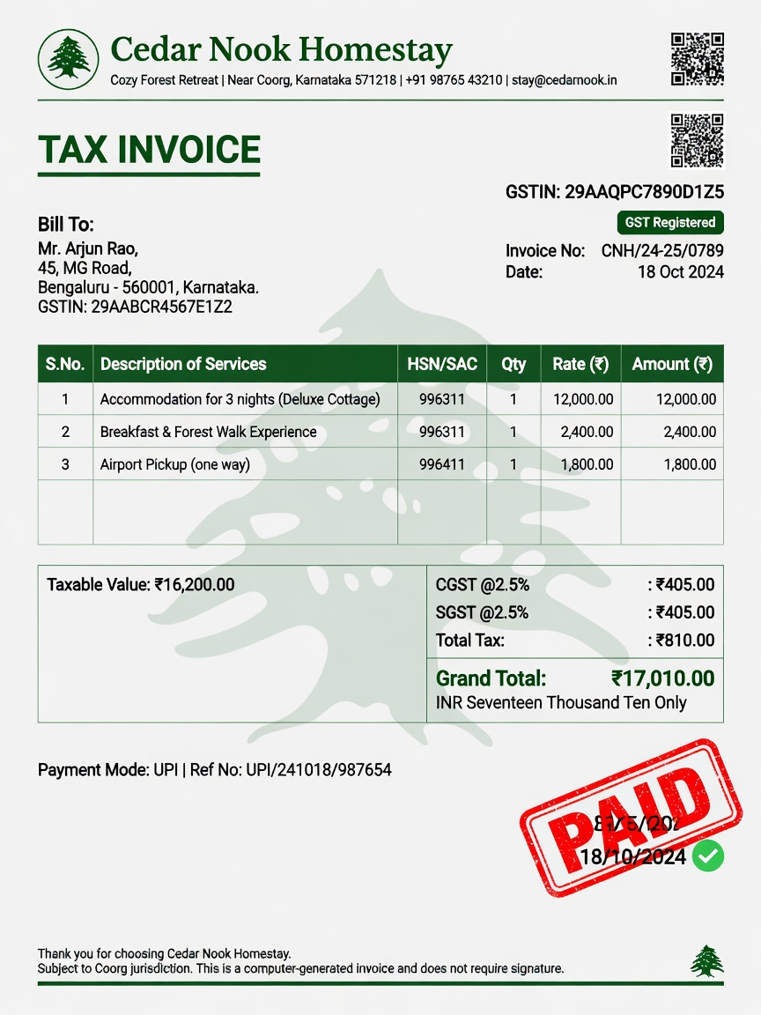
02-owner-dashboard
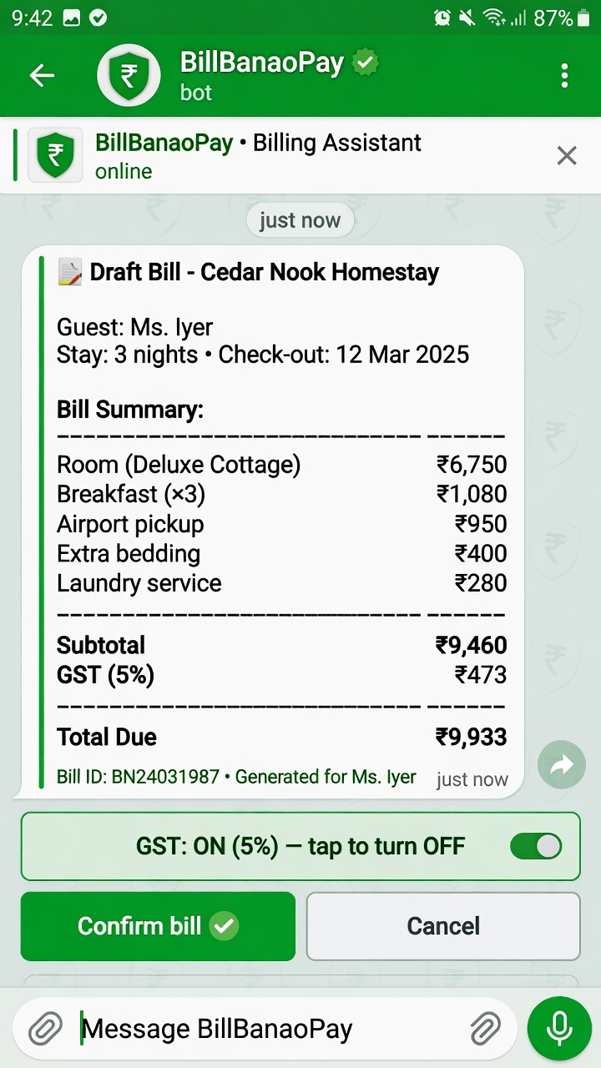
03-tax-invoice-pdf
